URL: <http://yourdentist.co.za/>

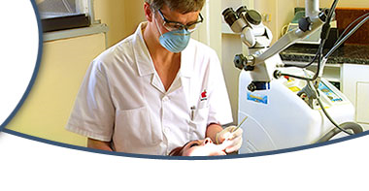 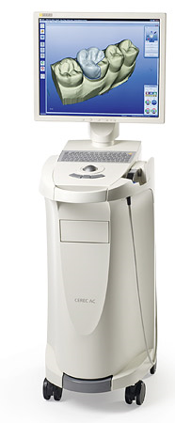

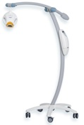 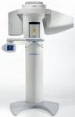

In our practices, (Medforum, Moreleta Park, Sandton) we can provide our patients with the highest standards of dentistry. With the aid of computers, we are able to manufacture veneers, crowns, fillings, while the patient is in the dental office. The placement of implants are also mostly done in the dental office, instead of having general anesthetic

Thanks to computerized technology, lasers and microscopes, dentistry is something to become excited about and promotes health instead of fear.   
  
People do not have to have   
  
- yellow teeth  
- teeth lost  
- silver fillings  
- pain  
- dentures  
- bad breath  
- gum disease

**Services:**

**Diagnostic service**  
The key to solving any dental problem is diagnosing it without a proper diagnosis no problem will ever be solved permanently  
We use the following tools to help us  
- All patients need good inta and extra oral diagnostic photos so we can document everything – we use a variety of very special cameras  
  
- All patients need a good set of x-rays –today these are all digital and available immediately – x-rays will show us everything we can’t see in the mouth we need to see inside the bone as well  
  
-The latest on the market is also available now – a full 3 D cat scan all in our office so no more guessing now we can really see everything live in 3d an awesome experience and only available with us

**Restorative dentistry with Cerec 3 D**  
All restorations should be completely invisible and last a lifetime. Natural and aesthetic restorative work is made possible with CAD/CAM Cerec technology

**Laser dentistry**  
With a Biolase waterlase and Diode lasers we do periodontal treatment and fillings

Implant dentistry with Southern and Nobel Biocare implants   
  
Often we can replace your tooth in a single visit using state of the art technology – today nobody should have dentures everybody deserves a permanent set of teeth

**Cosmetic veneers and crowns**  
This is our passion the cosmetic work all done onsite by our highly experienced team – we have made more than 11000 veneers over the last 15 years – and truly understand today’s estetic demands

**Pediatric dentistry**  
  
Lasers have made this all possible and today we can treat even the little ones without fear or pain

**Microscope dentistry**  
You can not fix what you can not see! Zeiss microscopes and loupes ate used to look down those difficult root canals

**Oral hygiene**  
No treatment is complete if we can not teach you and help you to maintain it – we have an innovative hygiene program for the whole family starting as young as 2 years old our team of 5 hygienists will take care of you

**Laser and ZOOM!advanced bleaching of teeth**  
Your quick fix for a brilliant white smile. Treatment is done within an hour with amazing results

**CEREC 3D training for dentists**  
Three of our team are world computerized dental society certified cerec 3d trainers .Cerec 3d training from basic to advanced veneer work is done on a regular basis locally and internationally

**Facilities:**

Laser Technology

CEREC CAD/CAM ceramic manufacturing systems and milling units PerioScan Professional cleaning and diagnostic unit

ZOOM Advanced teeth whitening system Galileos 3D CT Scanner

Bridge and Implant technology.

Zeiss Microscopes which facilitates in doing digital RCT.

Sirona Panoramic digital X-Rays.

Digital X-Rays.

High tech Intra-oral cameras.

Stain and glazing ovens for Cerec restorations.

Oral Hygienists & Oral hygiene programs.

**Doctor’s credentials:**

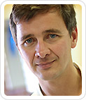 B.Ch.D (Pretoria) 1992

Dip.Odont (Oral surgery) 1998

World computerized dentistry society, accred. date 2002

ISCD Trainer

---------------------------------------------------------------

Dr Marx lectures in the use of lasers and CEREC 3 Ceramic Reconstruction as well as financial practice management

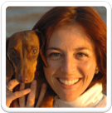 **Ade Meyer** B.Ch.D (Stellenbosch)  
  
  
Dip.Odont (Oral surgery) Cum Laude  
  
  
ISCD Trainer

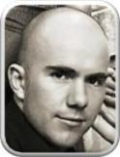 **Wynand merwe** B.Ch.D (Pretoria.)  
  
  
Dip.Odont (Aesthetic Dentistry)

**Contact us:**

**Medforum** Contact person:

Bronwyn Edkins - (Practice Manager)

Telephone:   +27 12 322 1170

Cell:   +27 83 375 0152

Fax:   +27 12 320 0565

E-mail:   [bronwyn@yourdentist.co.za](mailto:bronwyn@yourdentist.co.za?cc=drmarx@yourdentist.co.za)

Physical address:

 512 Medforum   
412 Schoeman St.  
Pretoria  
0002

**Moreleta Park** Contact person:

Gretel Senekal - (Oral Hygienist)

Telephone:   +27 12 998 6931

Cell:   +27 72 189 3382

Fax:   +27 12 998 6710

E-mail:   [gretel@yourdentist.co.za](mailto:gretel@yourdentist.co.za?cc=ade@oostvallei.com) Physical address:

882 Rubenstein Road.  
Moreletapark  
Pretoria  
0044

**Grayston Medical Mews**: Suite G Contact person:

Albena Helwick - (Dental assistant) Telephone:   +27 11 883 7095 Cell:   +27 79 886 1218 Fax:   +27 11 883 7095 E-mail:   [sandton@yourdentist.co.za](mailto:sandton@yourdentist.co.za?cc=wynandvdmerwe@yourdentist.co.za)

Physical address:

134 Grayston Drive  
Sandton  
2146